**GEN AI**

**AI CONTENT DETECTION USE CASE**

**SYNOPSIS**

* **INTRODUCTION**
* **METHODOLOGY**
* **ONLINE TOOLS FOR AI CONTENT DETECTION**
* **RULES**
* **EVIDENCES**
* **PROMPT ENGINEERING**
* **LIMITATIONS**
* **CONCLUSION**
* **REFERENCES**

**INTRODUCTION**

* The proliferation of artificial intelligence (AI)-generated content, particularly from models like ChatGPT, presents potential challenges to academic integrity and raises concerns about plagiarism.
* This study investigates the capabilities of various AI content detection tools in discerning human and AI-authored content.
* Fifteen paragraphs each from ChatGPT Models 3.5 and 4 on the topic of cooling towers in the engineering process and five human-witten control responses were generated for evaluation.
* AI content detection tools developed by OpenAI, Writer, Copyleaks, GPTZero, and CrossPlag were used to evaluate these paragraphs.
* Findings reveal that the AI detection tools were more accurate in identifying content generated by GPT 3.5 than GPT 4.
* However, when applied to human-written control responses, the tools exhibited inconsistencies, producing false positives and uncertain classifications.
* This study underscores the need for further development and refinement of AI content detection tools as AI-generated content becomes more sophisticated and harder to distinguish from human-written text.

**METHODOLOGY**

* The ChatGPT chatbot generated two 15-paragraph responses on "Application of Cooling Towers in the Engineering Process."
* The first set was generated using ChatGPT's Model 3.5, while the second set was created using Model 4. The initial prompt was to "write around 100 words on the application of cooling towers in the engineering process."
* Five human-written samples were incorporated as control samples to evaluate false positive responses by AI detectors.
* These samples were chosen from the introduction sections of five distinct lab reports penned by undergraduate chemical engineering students.
* The reports were submitted and evaluated in 2018, a planned selection to ensure no interference from AI tools available at that time.

**ONLINE TOOLS FOR AI-DETECTION**

* Copy Leaks
* ZeroGPT
* Detect GPT
* ChatGPT
* Google Bard
* Hugging chat
* Writer AI Content detector
* Contentdetector.ai
* CrossPlag

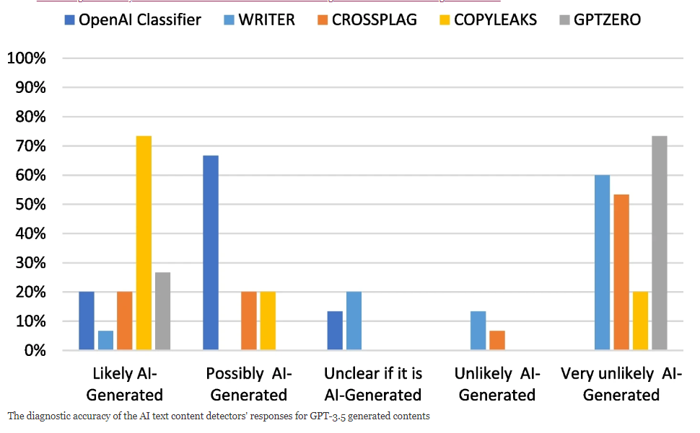

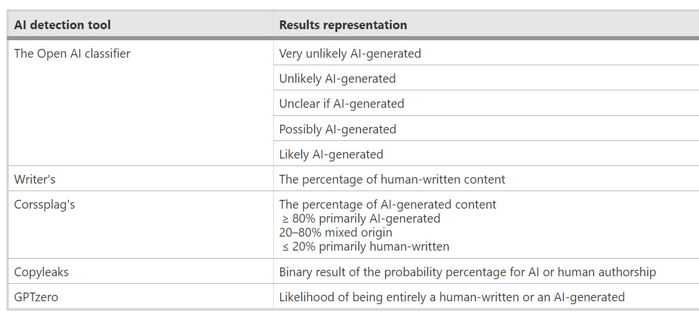

**RULES**

**EVIDENCES**

* CASE 1: Human-generated text without any grammatical, or spelling errors and within the context of the topic

India, a country known for its bustling streets and chaotic traffic, is undergoing a transformative journey in its urban transportation sector, with the rapid expansion of metro rail networks. The metro project discussions for the metropolitan cities have been underway since the late 1990's. These projects, characterized by their efficiency and environmental benefits, have not only eased the burden on the existing transportation infrastructure but have also redefined the way people commute in major cities. One of the most ambitious metro rail projects in India is the Delhi Metro. Since its inception in 2002, it has grown into a sprawling network with multiple lines, covering over 380 kilometers. It serves as a lifeline for millions of people daily, offering a reliable, comfortable, and time-saving mode of transportation in the national capital. Similar metro systems have taken root in cities like Mumbai, Kolkata, Bengaluru, Chennai, Hyderabad, and more. The impact of these projects extends far beyond the immediate relief from traffic congestion. They significantly reduce pollution and carbon emissions by encouraging citizens to opt for public transportation instead of private vehicles. The environmental benefits are complemented by reduced fuel consumption, making a substantial contribution to the nation's commitment to sustainability and combating climate change. Furthermore, metro rail projects stimulate economic development by connecting different parts of a city. They create employment opportunities, support local businesses, and facilitate accessibility to educational and healthcare institutions. Real estate development often follows these transport corridors, contributing to urban renewal. Notably, these projects are a testament to India's engineering prowess. They involve intricate planning and execution, with underground, elevated, and at-grade sections, all designed to minimize disruption to existing infrastructure and ensure passenger safety. Advanced technologies, including automatic fare collection and state-of-the-art rolling stock, make for a seamless and secure travel experience. As we look to the future, India's metro rail network continues to expand. New cities, including Nagpur, Lucknow, and Ahmedabad, have embraced the metro system as a means of easing urban congestion. Proposed projects in cities like Kanpur, Varanasi, and Bhopal are in the pipeline, demonstrating the growing recognition of metro rail's benefits. Indian metro has indeed increased the job opportunities for several people. The metro rail revolution in India has not been without its challenges. Overcrowding and maintenance are concerns that need continuous attention. Fare structures and last-mile connectivity remain focal points for improvement. However, the commitment of the government and urban planners to resolve these issues ensures that the metro rail system's growth will continue, serving as a crucial pillar of India's urban transportation landscape. In conclusion, metro rail projects in India have emerged as a game-changer in the realm of urban transportation. These initiatives not only alleviate traffic congestion and reduce pollution but also foster economic growth and modernize cityscapes. As India continues to invest in this transformative mode of transportation, it solidifies its place as a global leader in sustainable and efficient urban development, promising a brighter and more connected future for its citizens. On completion, the Indian metro service along with the Indian sub-urban railway service together is anticipated to ease out the local traffic tension across the major cities of the sub-continent.

* **ZERO GPT**

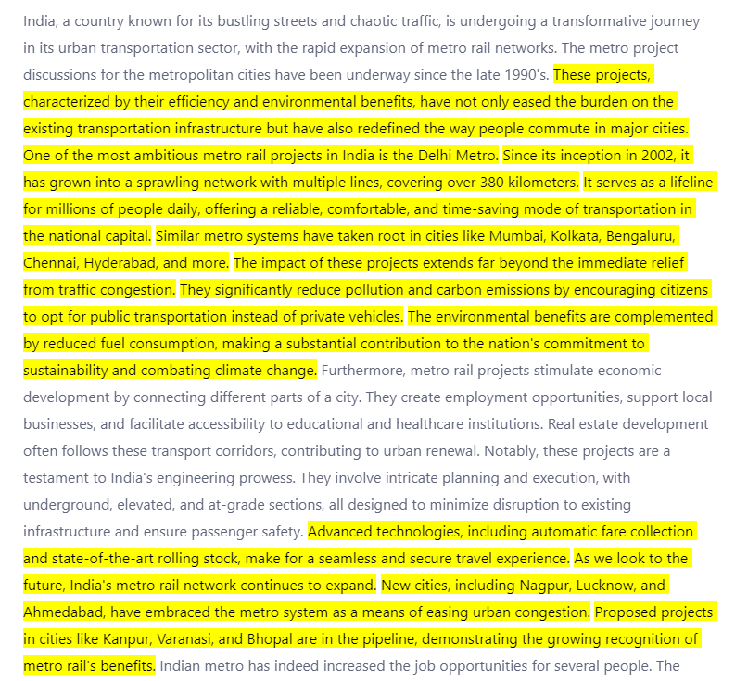

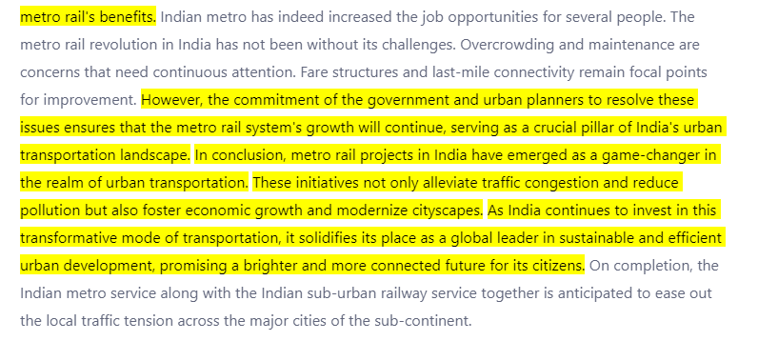

Inference: Zero GPT has identified all the human-generated text, but in addition, it has also failed to highlight a few more AI-generated text.

* **COPY LEAKS**

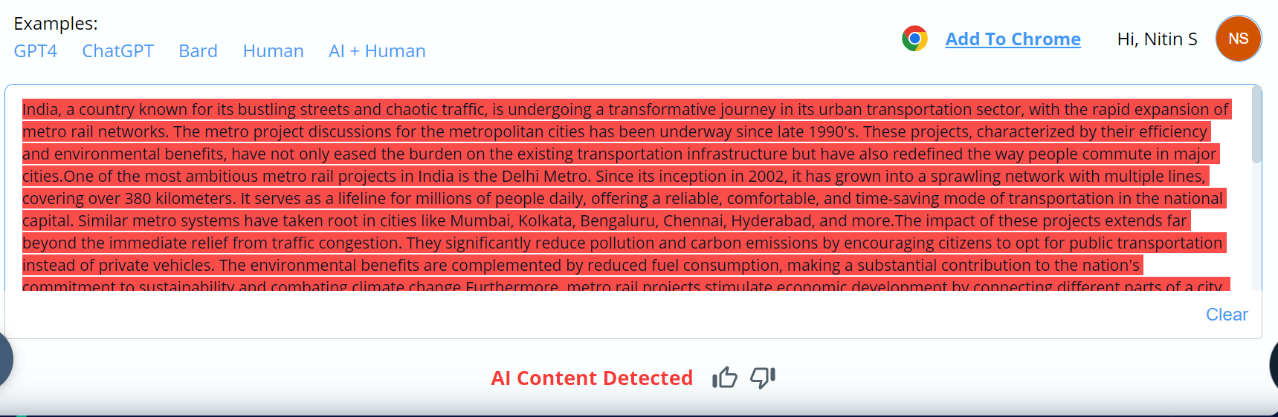

Inference: Copy Leaks has identified that all the sentences within the paragraph is AI detected which is incorrect

* **GRAMMARLY AI**

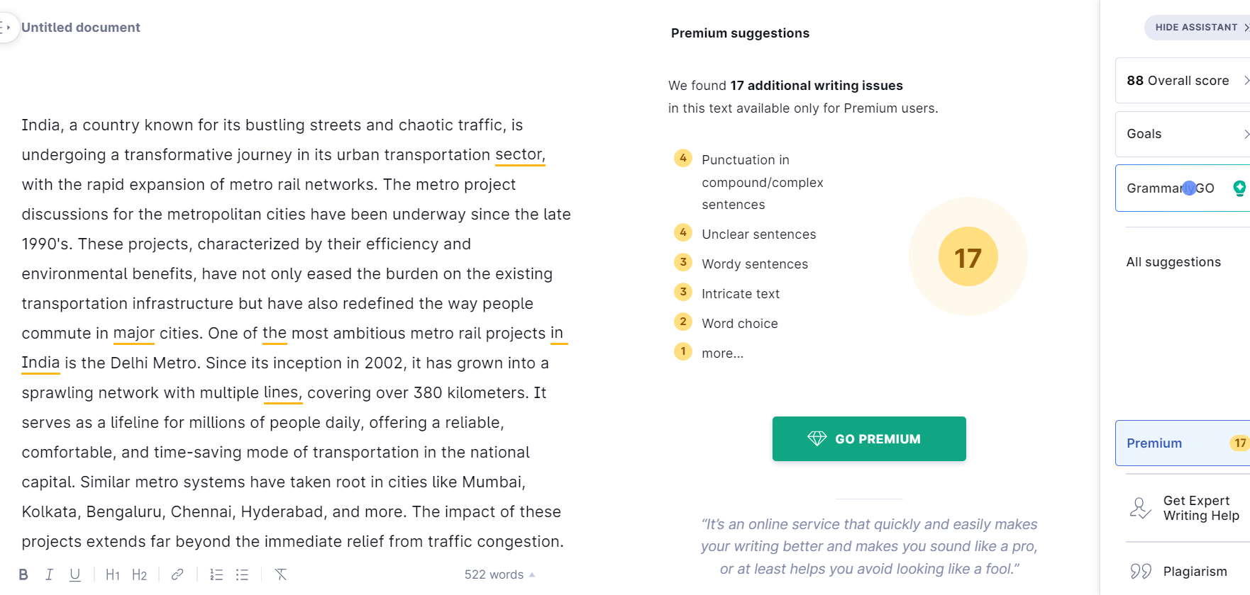

Inference: Grammarly AI is more of an error correction tool that identifies the errors in the sentences and suggests the correct output for the same

* **CHATGPT**

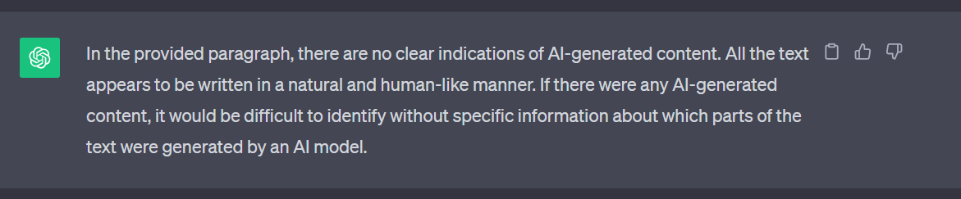

Inference: ChatGPT has failed to distinguish the human-generated text in the paragraph. Claims that the entire paragraph is human-generated which is incorrect.

* **GOOGLE BARD**

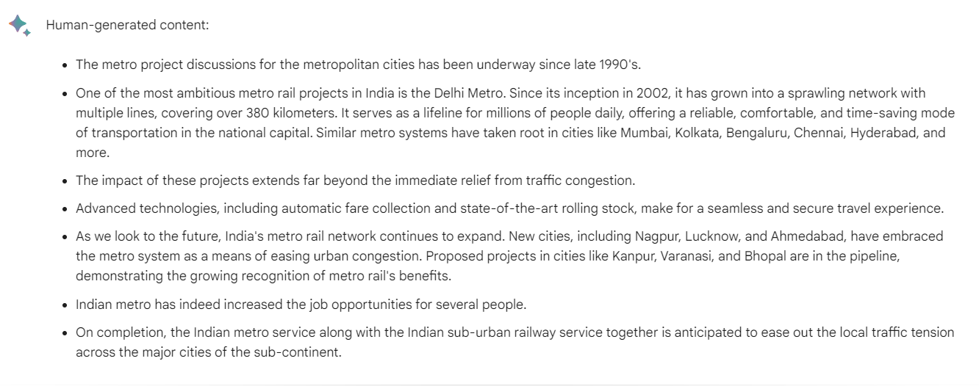

Inference: Google Bard has identified all human-generated sentences. It has detected 4 ai-generated sentences as human-generated. Hence Google Bard is not an accurate detector.

* **HUGGING CHAT**

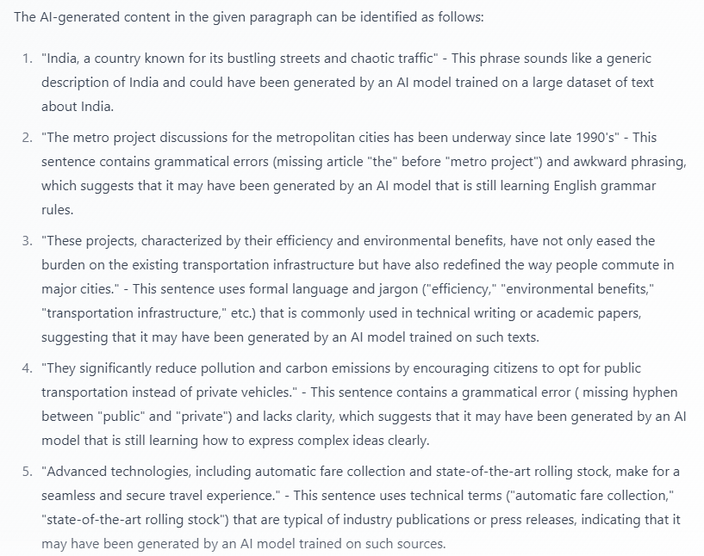

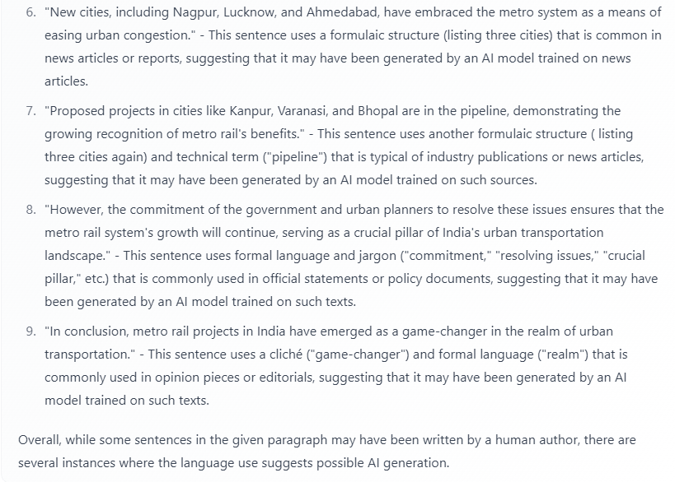

Inference: Hugging chat with ‘meta-llama/Llama-2-70b-chat-hf’ model has taken into consideration that the ai-generated content will contain the following

* Generic description of the topic
* Awkward phrasing
* Formal language and jargon
* Grammatical errors and lack of clarity
* Highly technical terms
* Uses formulaic structure (listing 3 cities)
* Usage of cliché

The above consideration will lead to inconsistency and in-accuracy of ai-content detection

* **WRITER.AI**

This online tool has character limitation of 1500 words

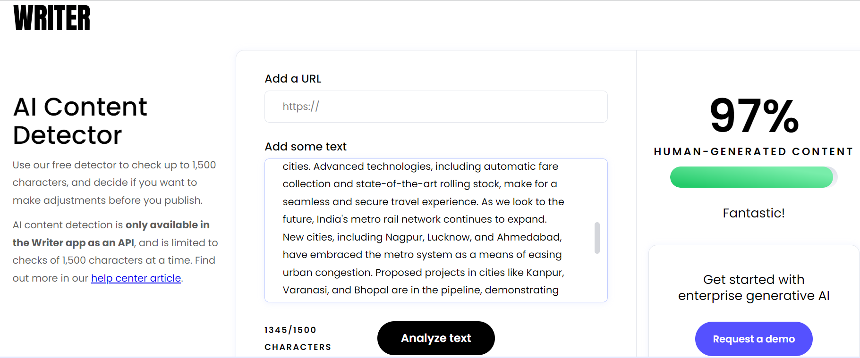

Inference: Writer.com has identified that 97% of the paragraph is human generated which is incorrect. Apparently, it has not stated which sentence is ai-generated and so this cannot serve us in this use case.

* **CONTENTDETECTOR.AI**

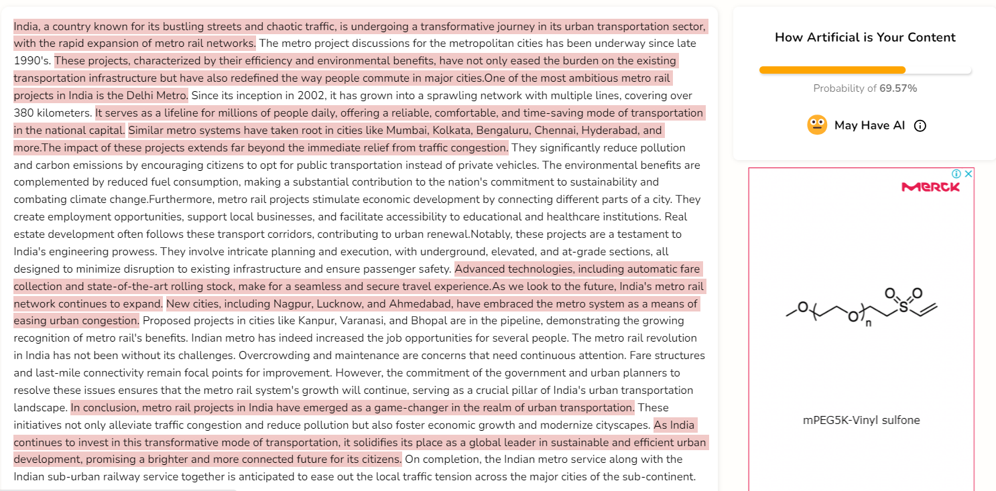

Inference: Contentdetector.ai has produced incorrect results as it identifies most of the ai-generated text as human-generated

* **CROSSPLAG**

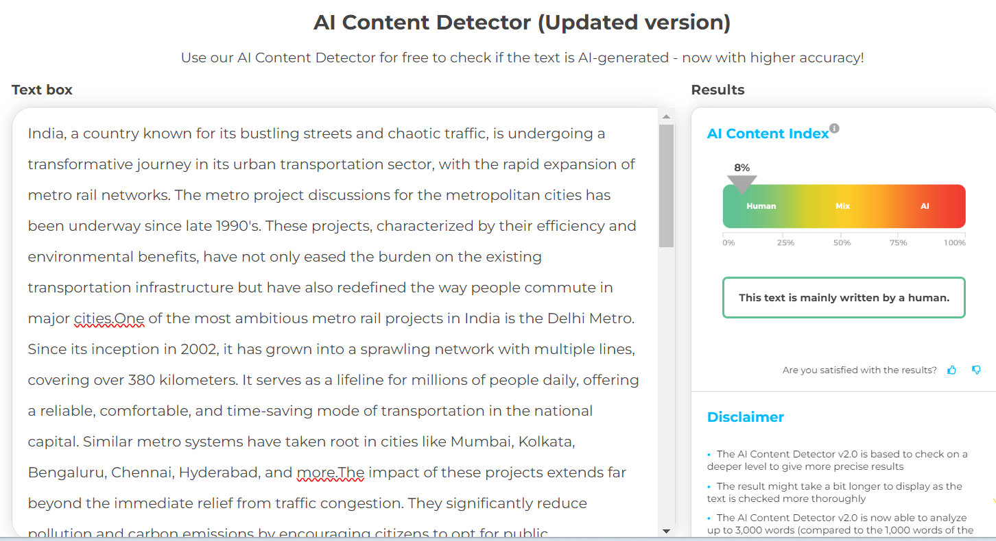

Inference: Crossplag has identified that only 8% of the paragraph is ai-generated which is incorrect.

* CASE 2: Human-generated text with grammatical, and spelling errors and within the context of the topic

Cricket, often referred to as a religion in India, is set to take center stage once again as the nation eagerly prepares to host the ICC Cricket World Cup in 2023. Cricket fans all across the world will be on cloud nine to see their favourite cricket stars performing on a big stage. The tournament, a pinnacle event in the cricketing world, is poised to bring together teams from around the globe for an exciting showcase of talent, competition, and the spirit of the sport. India's love affair with cricket runs deep, and the country's hosting of the 2023 World Cup is a cause for celebration, promising an unforgettable spectacle for fans and players alike. Being the biggest event with respect to the cricket fraternity, this edition of 50 over World Cup is going to be a fierce battle between the best of the bests. The tournament is scheduled to be held in various iconic cricketing venues across India, creating an atmosphere steeped in history and tradition. One of the most anticipated aspects of the World Cup is the participation of cricket's top teams, with players who have etched their names into the annals of the sport. Fans can expect fierce rivalries and thrilling contests as these cricketing giants compete for the coveted trophy. The 2023 World Cup is particularly special as it coincides with the 50th anniversary of the tournament's inception. This landmark event adds an extra layer of nostalgia and significance, underscoring India's role as a custodian of cricketing heritage. While the tournament promises cricketing excitement of the highest order, it also brings a significant economic boost to the host nation. Cricket World Cups have consistently been a catalyst for tourism, with fans from around the world traveling to India to witness the action firsthand. This influx of visitors has a positive impact on local businesses, hospitality, and the economy as a whole. In preparation for the event, India has been investing in upgrading and modernizing its cricket infrastructure. Renovations and improvements to stadiums, training facilities, and fan amenities have been a priority. The objective is to provide an unparalleled experience for both players and spectators, with a focus on safety, comfort, and entertainment. The broadcasting right for the telecast of each match of the tournament has been sold for a whooping sum. The significance of the 2023 World Cup extends beyond the sporting arena. It serves as an opportunity for India to showcase its organizational capabilities on a global stage. Hosting an event of this magnitude involves intricate planning and seamless execution, ranging from security measures to logistics and transportation. It's a testament to India's ability to successfully manage such massive international gatherings. The World Cup also shines a spotlight on the diverse culture and rich heritage of India. Teams and fans from different corners of the world will get a taste of the country's vibrant traditions, delectable cuisine, and warm hospitality. The tournament serves as a platform for cultural exchange, fostering understanding and camaraderie among cricket enthusiasts from various nations. As the countdown to the 2023 ICC Cricket World Cup continues, excitement and anticipation are building. Cricket lovers around the globe eagerly await this cricketing extravaganza in India, where the sport is not just a game but a way of life. The World Cup promises to be a testament to the enduring passion for cricket in the country, where history, tradition, and a love for the sport converge in a celebration of excellence on the field. The stadiums that are hosting the games have been renovated with astounting banners, and seats with packed security like never before. Though it is a tough task for the hosting country with respect to providing visas for the foreigners visiting India to support their countrymen playing the sport, the sub-continent is ready to welcome the world, and the 2023 World Cup is poised to be a fitting tribute to the spirit of cricket.

* **ZERO GPT**

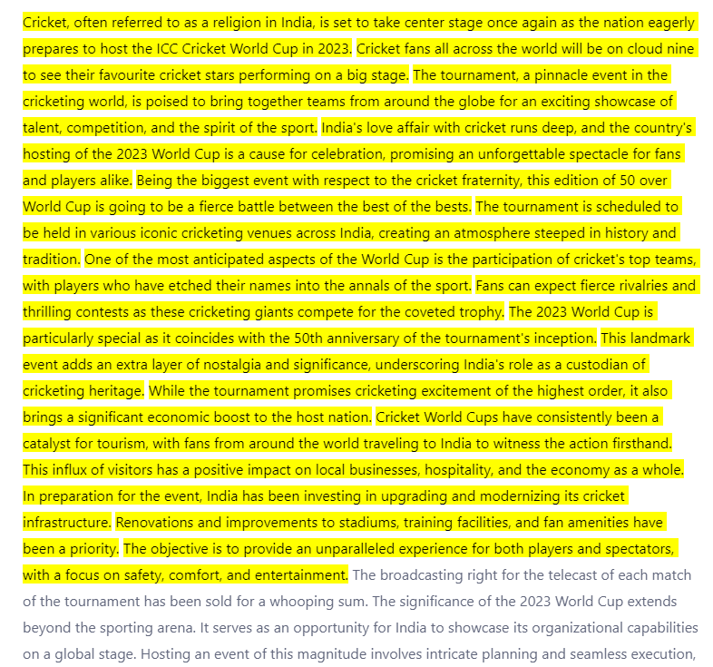

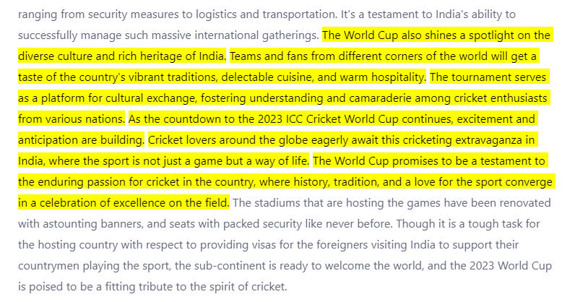

Inference: Zero GPT has identified only 2 out of 4 human-generated sentences in the paragraph. In addition to that, the tool has detected a few ai-content also as human-generated content. Hence the tool is inconsistent and inaccurate.

* **COPY LEAKS**

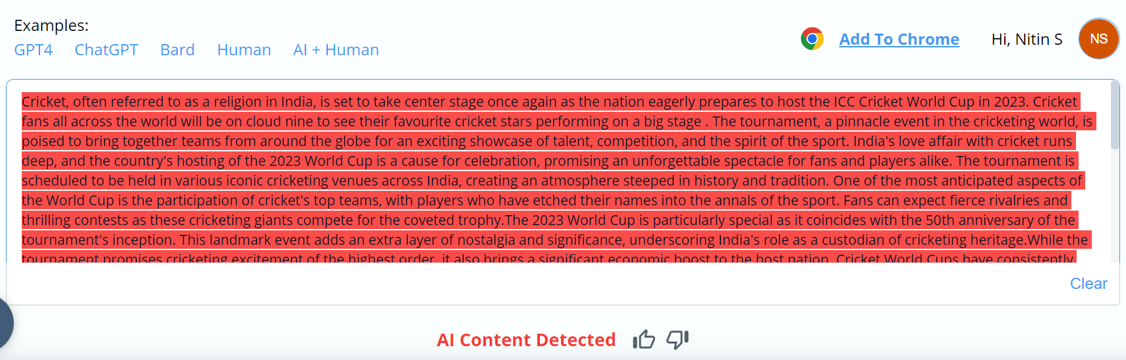

Inference: Copy leaks identify the whole paragraph to be ai-generated content which is incorrect.

* **CHATGPT**

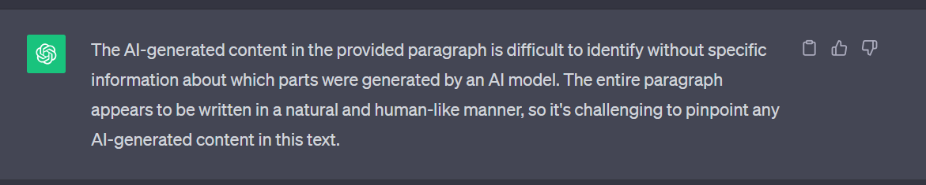

Inference: ChatGPT is giving the incorrect response

* **GOOGLE BARD**

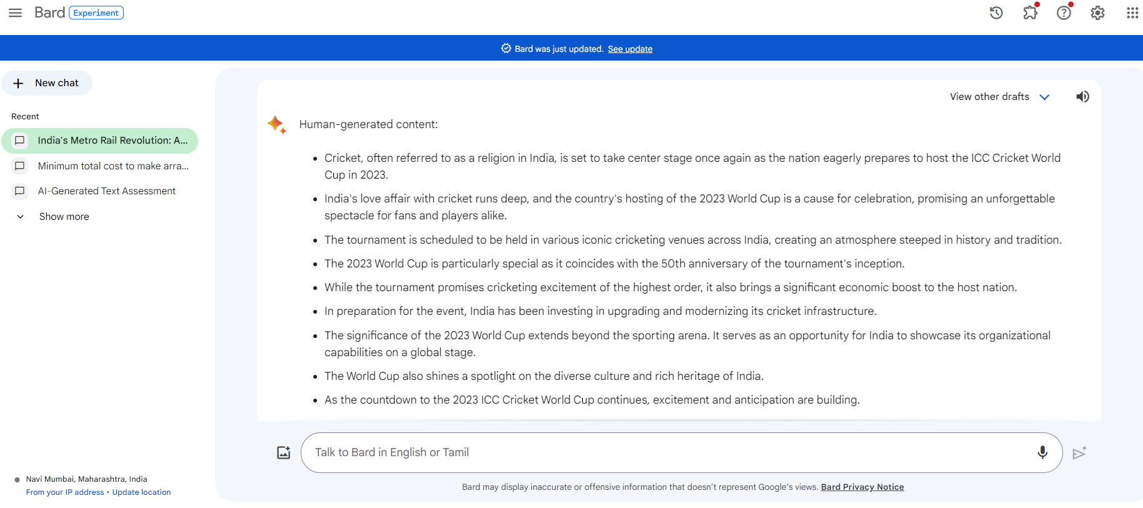

Inference: None of the listed output is human generated

* **HUGGING CHAT**

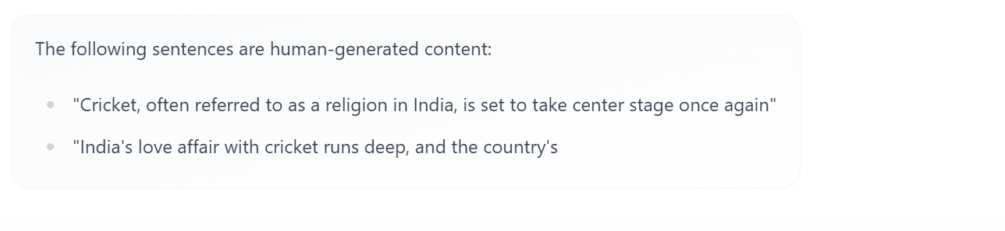

Inference: None of the listed output is human generated

* **WRITER.AI**

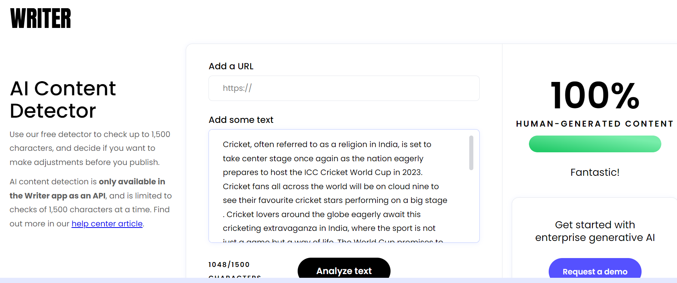

Inference: WRITER has detected the input paragraph as 100% human-generated

* **CONTENT DETECTOR**

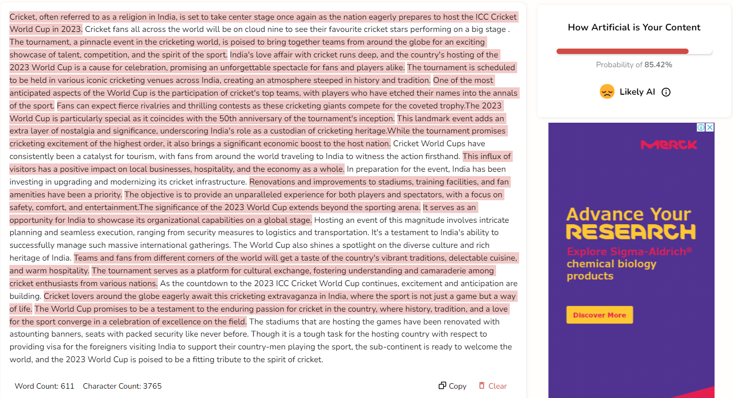

Inference: CONTENT WRITER has detected the input paragraph to be 85.42% ai-generated

* **CROSSPLAG**

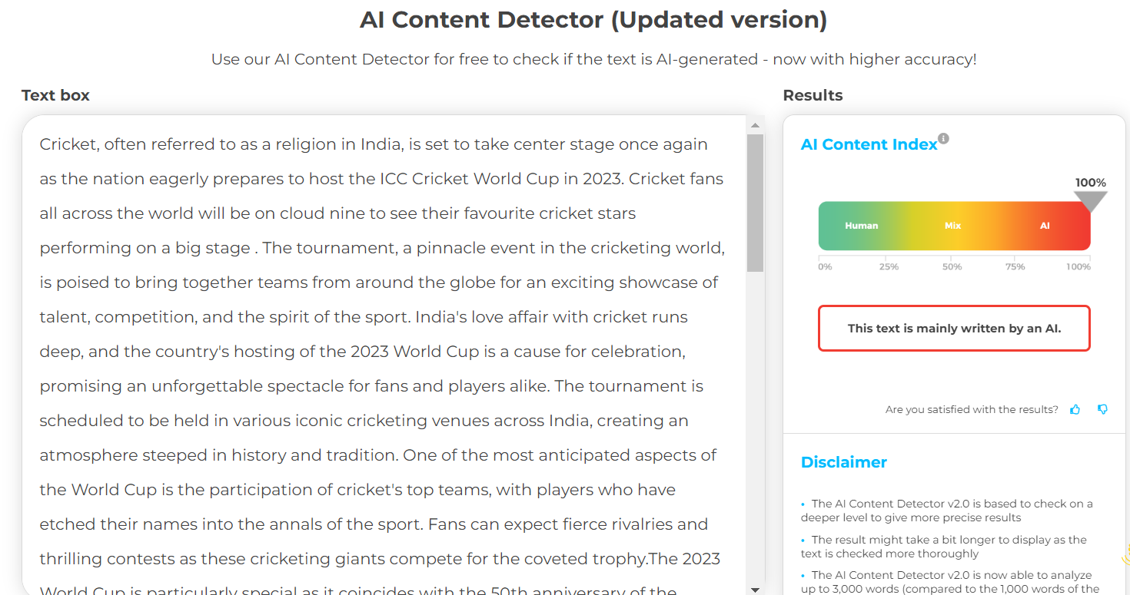

Inference: Crossplag has identified that the input paragraph is 100% ai-generated

* CASE 3: Human-generated text not within the context of the topic

India, a land of rich diversity and culture, is also known for its unique traffic landscape, a dynamic blend of chaos and order. The Indian road network, spanning millions of kilometers, connects bustling metropolises, serene villages, and everything in between. However, the cacophony of horns, the constant buzz of vehicles, and the intricate dance of road users make Indian traffic a spectacle that can be both fascinating and frustrating. One of the defining features of Indian traffic is its sheer volume. With a population of over 1.3 billion, the roads are teeming with cars, scooters, bicycles, pedestrians, and even the occasional livestock. The economic status of India has grown to be greater extent. In many Indian cities, traditional forms of transportation such as cycle rickshaws and hand-pulled carts share the road with modern vehicles. This mix of old and new, often in close proximity, exemplifies the coexistence of different eras. Moreover, road conditions can be challenging. Potholes, uneven surfaces, and congested lanes are a common sight. Youngsters nowadays prefer exotic bikes to modern bikes. The state of the roads, coupled with erratic weather patterns, can lead to hazardous driving conditions, especially during the monsoon season. Traffic rules and regulations exist, but adherence can vary widely. India's traffic law enforcement, while improving, often grapples with issues such as corruption and a lack of resources. This means that traffic violations like overloading vehicles, not wearing helmets, and jumping signals are frequently observed. Today is our day. Ride-sharing services and bicycle rental programs have gained popularity, providing alternative modes of transport. The food is quite expensive in Chennai. As India continues to modernize and urbanize, the issue of traffic will remain a critical one. There's a need for better road infrastructure, stricter enforcement of traffic rules, and investments in sustainable transportation solutions. The government is working on improving road safety and enhancing urban mobility, but progress is a complex and ongoing journey. In conclusion, Indian traffic, with its blend of challenges and resilience, is a reflection of the country's unique character. It's a microcosm of India's diversity, and it presents a snapshot of the nation's progress and its areas of development. The weather conditions have deteriorated day by day. Navigating Indian traffic is not just a matter of reaching a destination; it's an experience that, like the country itself, can be both perplexing and rewarding.

* ZEROGPT

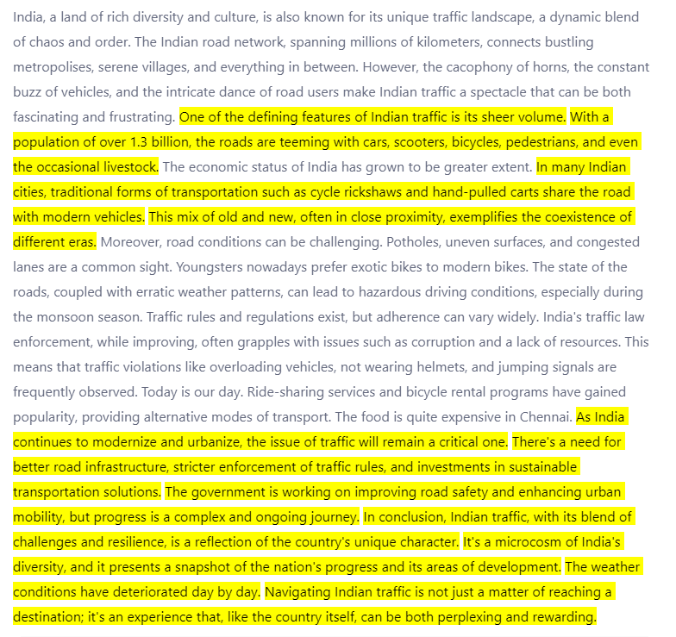

Inference: ZeroGPT failed to identify all human-generated sentences. Also, some of the ai-generated content are identified as human-generated.

* COPYLEAKS

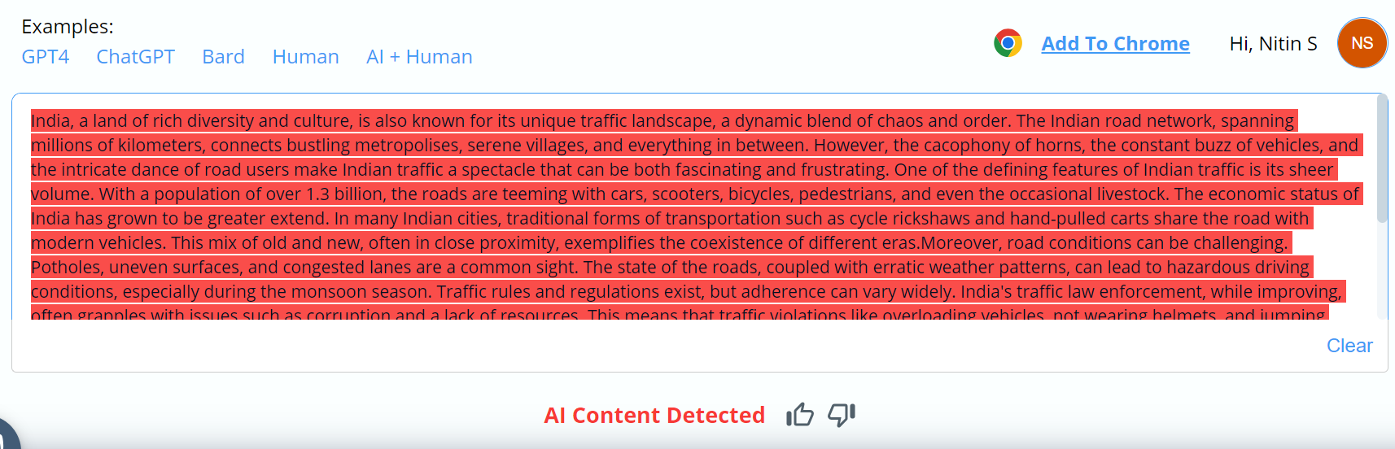

Inference: Copyleaks identifies the entire paragraph as AI-generated

* CHATGPT

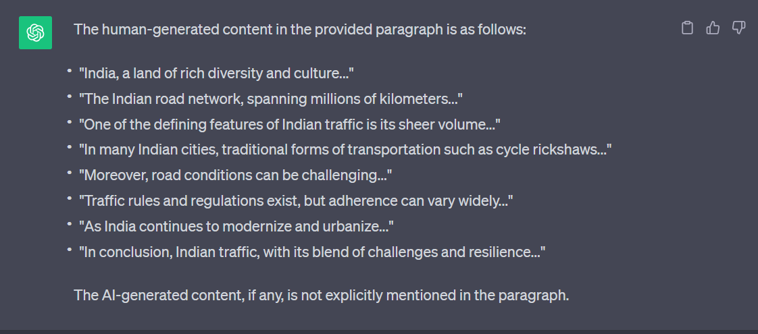

Inference: ChatGPT was inconsistent and in-accurate

* GOOGLE BARD

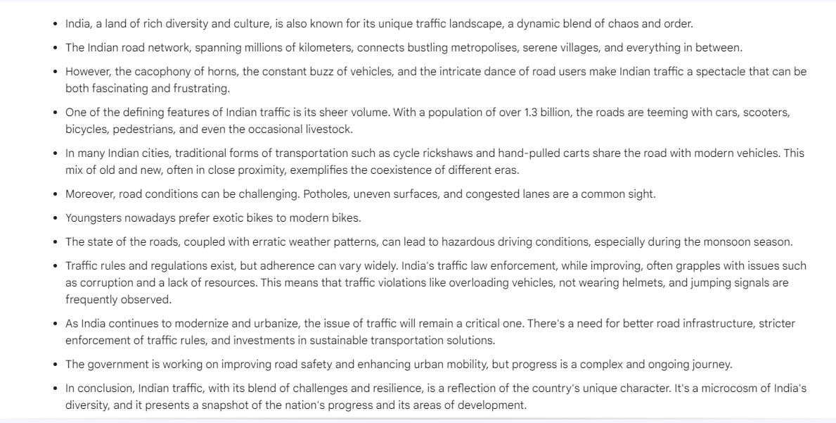

Inference: Google Bard has identified many ai-content as human generated texts

* WRITER

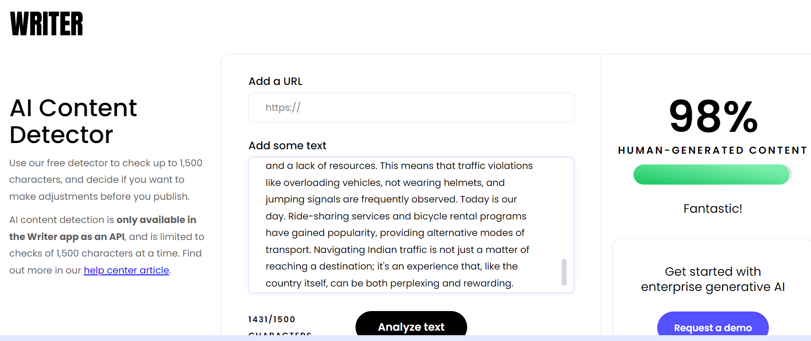

Inference: Writer.com has identified the paragraph to have 98% human-generated content which is incorrect

* CONTENT DETECTOR

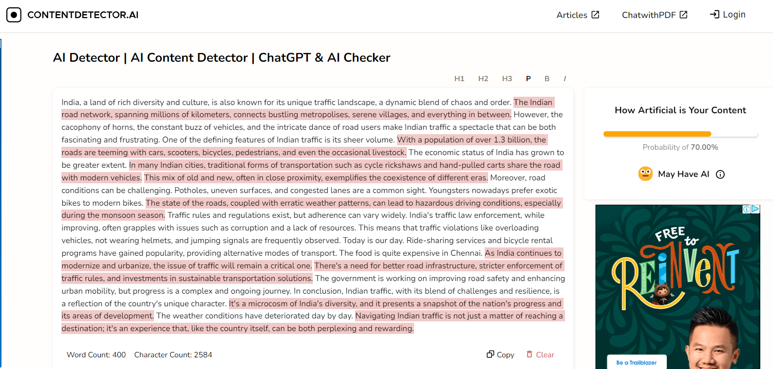

Inference: Inaccurate output

* CROSSPLAG

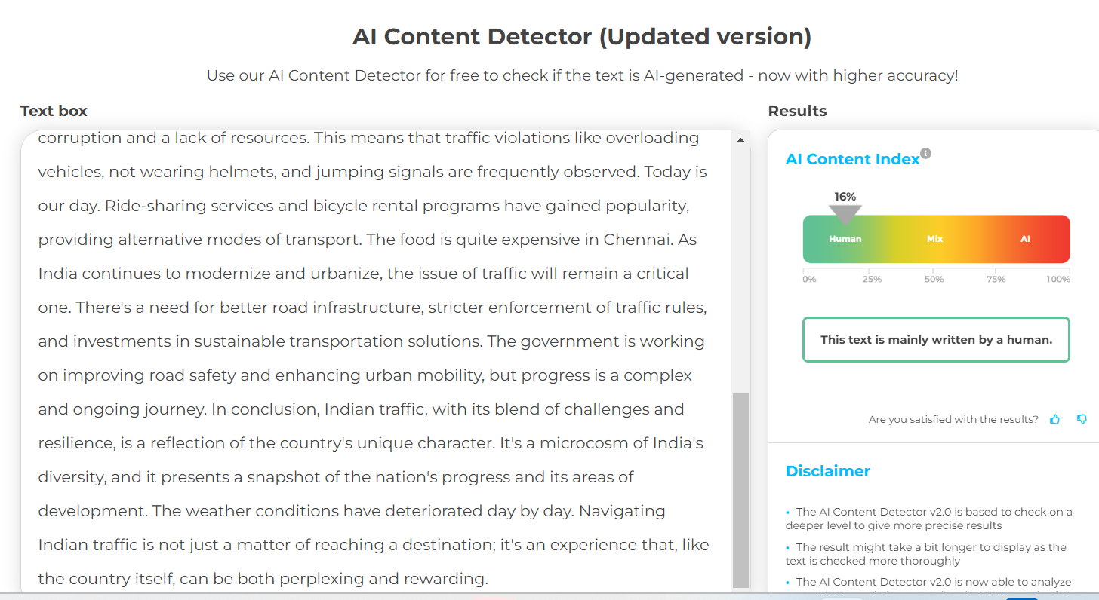

**PROMPT ENGINEERING**

**LIMITATION**

* OpenAi Classifier

*As of July 20, 2023, the AI classifier is no longer available due to its low rate of accuracy. We are working to incorporate feedback and are currently researching more effective provenance techniques for text and have made a commitment to develop and deploy mechanisms that enable users to understand if audio or visual content is AI-generated.*

*We’ve trained a classifier to distinguish between text written by a human and text written by AIs from a variety of providers. While it is impossible to reliably detect all AI-written text, we believe good classifiers can inform mitigations for false claims that AI-generated text was written by a human: for example, running automated misinformation campaigns, using AI tools for academic dishonesty, and positioning an AI chatbot as a human.*

*Our classifier is not fully reliable. In our evaluations on a “challenge set” of English texts, our classifier correctly identifies 26% of AI-written text (true positives) as “likely AI-written,” while incorrectly labeling human-written text as AI-written 9% of the time (false positives). Our classifier’s reliability typically improves as the length of the input text increases. Compared to our previously released classifier, this new classifier is significantly more reliable on text from more recent AI systems.*

* ONLINE TOOLS

*The tools analyzed in this study were only those developed by OpenAI, Writer, Copyleaks, GPTZero, and CrossPlag corporations. These AI detectors were selected based on extensive online research and valuable feedback from individual educators at the time of the study. As per the Cases addressed and evidences collected it is understood that the online tools for this use case is providing less accurate or inconsistent result and hence cannot be relied on.*

**CONCLUSION**

* The present study sought to evaluate the performance of AI text content detectors, including OpenAI, Writer, Copyleaks, GPTZero, and CrossPlag.
* The results of this study indicate considerable variability in the tools' ability to identify and categorize text as either AI-generated or human-written, with a general trend showing a better performance when identifying GPT 3.5-generated content compared to GPT 4-generated content or human-written content.
* It is understood that the tools taken for this case study suggest that the tools are not able to accurately distinguish the ai AI-generated and human-written content.
* The accuracy differs for different cases like if we mix human-generated text with ai-generated text and also with the grammatical/spelling errors, content within/not within the scope of the actual topic.
* In conclusion, as AI text generation evolves, so must the tools designed to detect it.
* This necessitates continuous development and regular evaluation to ensure their efficacy and reliability.
* Furthermore, a balanced approach involving AI tools and traditional methods best upholds academic integrity in an ever-evolving digital landscape

**REFERENCES**

* <https://edintegrity.biomedcentral.com/articles/10.1007/s40979-023-00140-5>
* <https://www.zerogpt.com/>
* <https://copyleaks.com/ai-content-detector>
* <https://chat.openai.com/>
* <https://bard.google.com/chat>
* <https://huggingface.co/chat>
* <https://writer.com/ai-content-detector/>
* <https://contentdetector.ai/>
* <https://app.crossplag.com/individual/detector>